

Submitted By:
Umair Umar CE-25-107
Assignment:
CA Lab No. 4
Submitted To:
Mehmood
For the fulfillment of,
Circuit Analysis Lab
Department of Computer Engineering
University of Engineering and Technology, Lahore

Circuit Analysis – Lab 4
Proteus Simulation Procedure

Introduction
This document describes the step-by-step procedure followed to simulate basic parallel circuits in Proteus Design Suite. Since a physical DMM was not available, a DC Ammeter and DC Voltmeter from the Proteus virtual instruments panel were used for measurements. A Battery was used as the DC voltage source, added through the component search (parts list) in the same way as resistors.

Components Used
The following components were used in both simulation tasks:

Component | Name in Proteus | How to Add
DC Voltage Source | BATTERY | Search in Parts List (P)
Resistors | RES | Search in Parts List (P)
DC Ammeter | DC AMMETER | Left instrument panel (Virtual Instruments)
DC Voltmeter | DC VOLTMETER | Left instrument panel (Virtual Instruments)

General Setup Procedure in Proteus

Step 1: Open Proteus and Start a New Project
- Launch Proteus Design Suite.
- Go to File > New Project and create a new schematic project.
- The ISIS schematic editor window will open.

Step 2: Add Resistors from the Parts List
- Click the Component icon (P) on the left toolbar to open the Pick Devices (Parts List) window.
- In the search box, type RES and press Enter.
- Select the RES component from the results and click OK.
- Place the required number of resistors on the schematic by clicking on the canvas.
- Double-click each resistor to open its properties and set the resistance value (e.g., 10k, 2k, 1k).

Step 3: Add the Battery (DC Voltage Source)
- Click the Component icon (P) again to open the Parts List.
- In the search box, type BATTERY and press Enter.
- Select BATTERY from the results and click OK.
- Place the battery on the schematic.
- Double-click the battery and set its voltage to 9V in the properties dialog.

Step 4: Add DC Ammeter and DC Voltmeter
- On the left-side panel of Proteus, click the Virtual Instruments icon (looks like an oscilloscope/meter icon).
- From the list that appears, select DC AMMETER and place it on the schematic. Repeat and place one ammeter per resistor branch.
- Similarly, select DC VOLTMETER from the same list and place it on the schematic across the nodes where voltage is to be measured.

Step 5: Wire the Circuit
- Use the Wire tool (W key or from toolbar) to connect all components.
- Connect the positive terminal of the battery to the top rail of the parallel circuit.
- Connect all resistors in parallel between the top and bottom rails.
- For each resistor branch, insert the DC Ammeter in series by breaking the wire and placing the ammeter in line with the resistor.
- Connect the DC Voltmeter in parallel across the two nodes where voltage is to be measured (positive probe to the higher potential node, negative probe to the lower).
- Connect the negative terminal of the battery to the bottom rail (ground).
- Add a ground terminal to the negative rail using the Ground symbol from the left toolbar.

Task 1 Simulation – Three Resistors in Parallel

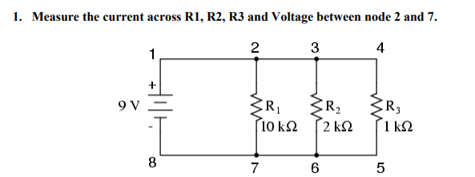
Circuit: 9V Battery, R1 = 10 kΩ, R2 = 2 kΩ, R3 = 1 kΩ, all in parallel.

Measurement Procedure:
1. Build the circuit as described in the General Setup above with three resistors and three ammeters (one per branch).
2. Place the DC Voltmeter across nodes 2 and 7 (the top and bottom rails of the parallel section).
3. Run the simulation by clicking the Play button (green triangle) at the bottom of the screen.
4. Read the current value displayed on each DC Ammeter for R1, R2, and R3.
5. Read the voltage value displayed on the DC Voltmeter between nodes 2 and 7.
6. Record all readings in the practical values table.

Note: The ammeter must always be connected in series with the resistor. Connecting it in parallel will short-circuit the branch.

Task 2 Simulation – Four Resistors in Parallel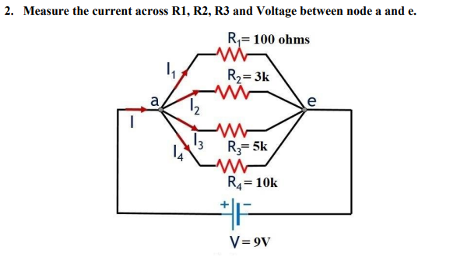
Circuit: 9V Battery, R1 = 100 Ω, R2 = 3 kΩ, R3 = 5 kΩ, R4 = 10 kΩ, all in parallel.

Measurement Procedure:
1. Build the circuit with four resistors connected in parallel between nodes a and e, each with its own DC Ammeter in series.
2. Place the DC Voltmeter across nodes a and e.
3. Run the simulation by clicking the Play button.
4. Read and record the current through each resistor branch from the respective ammeter.
5. Read and record the voltage between nodes a and e from the voltmeter.
6. Stop the simulation after recording all values.

Note: All resistors share the same two nodes (a and e), so the voltage across each branch is equal to the source voltage of 9V. This is a fundamental property of parallel circuits.

Observations
The following observations were made during simulation:

1. The voltage measured across all parallel branches was equal to the supply voltage (9V) in both tasks, confirming the parallel circuit property.
2. The branch with the smallest resistance (R1 in Task 2, 100Ω) drew the highest current (approximately 90 mA).
3. The branch with the largest resistance drew the least current.
4. Simulated values matched theoretical values calculated using Ohm's Law (I = V/R), with only negligible rounding differences.

Conclusion
The Proteus simulation successfully verified the theoretical behaviour of parallel circuits. Using the DC Ammeter (in series) and DC Voltmeter (in parallel) along with a Battery as the 9V source, all measurements were obtained accurately. The simulation confirmed that in a parallel circuit, voltage remains constant across all branches while current divides according to the resistance of each branch.

